**WEATHER STATION**

**Features :**

* Wind Speed & direction
* Atmospheric Pressure
* UV
* Temperature
* Humidity
* Light Intensity
* Real-time data collection
* Long range Data transfer
* Data Visualisation Dashboard
* Weather Prediction

**Specifications :**

1. A3144 Magnetic Hall Sensor: <https://robu.in/product/hall-magnetic-sensor-module/>
   * Operating Voltage : 5V
   * Power consumption : 8mA
   * Datasheet : <https://www.elecrow.com/download/A3141-2-3-4-Datasheet.pdf>
2. DS18B20 Temperature Sensor: <https://robu.in/product/ds18b20-water-proof-temperature-probe-black-1m/>
   * Operating Voltage : 3-5.5V
   * Range : -55°C to +125°C
   * Accuracy : ±0.5 °C
   * Datasheet : <https://www.analog.com/media/en/technical-documentation/data-sheets/DS18B20.pdf>
   * Sensing pin pull up using 4.7k
3. DHT22 Temperature and Humidity Sensor (AM2302) : <https://robu.in/product/dht22-digital-temperature-humidity-sensor-temperature-humidity-module-am2302/>
   * Operating Voltage : 3-5.5V
   * Temp. Range : -40 to +80 ℃
   * Accuracy : ±0.5 °C
   * Humidity Range : 0 to 100%
   * Accuracy : ±2%
   * Datasheet : <https://www.sparkfun.com/datasheets/Sensors/Temperature/DHT22.pdf>
4. GY-30 BH1750FVI Light Sensor : <https://robu.in/product/gy-30-bh1750fvi-digital-light-intensity-illumination-sensor/>
   * Operating Voltage : 3-5V
   * Range : 0 to 65535 lux
   * Accuracy : 1 lux
   * Built-in 16-bit ADC
   * Datasheet : <https://www.mouser.com/datasheet/2/348/bh1750fvi-e-186247.pdf>
5. GY-BME280 Atmospheric Pressure Sensor : <https://robu.in/product/gy-bme280-3-3-precision-altimeter-atmospheric-pressure-sensor-module/>
   * Operating Voltage : 3.3V
   * Peak Current : 1.12mA
   * Pressure Range : 300-1100 hPa
   * Accuracy : ±1hPa
   * Datasheet : <https://5.imimg.com/data5/SELLER/Doc/2022/1/WG/FV/GY/1833510/gy-bmp280-3-3-high-precision-atmospheric-pressure-sensor.pdf>
6. DFRobot LTR390 UV Light Sensor : <https://robu.in/product/dfrobot-gravity-ltr390-uv-light-sensor-280nm-to-430nm-i2c-uart/>
   * Operating Voltage : 3.3-5V
   * Operating Current : 2.73mA
   * UVA Range : 280 to 430 nm
   * Address : 0x1C
   * Datasheet : <https://optoelectronics.liteon.com/upload/download/DS86-2015-0004/LTR-390UV_Final_%20DS_V1%201.pdf>
7. SX1278 LoRa Module : <https://www.electronicscomp.com/sx1278-lora-module-ra-02-433mhz-wireless-spread-spectrum-transmission?gclid=CjwKCAjwrranBhAEEiwAzbhNtR2vH4K4DIg6lcEBBsRZxT1aTu7Gt2Fxi7IRb_JxSCHkgcaw3MH3KxoCHlwQAvD_BwE>
   * Operating Voltage : 1.8- 3.7V
   * Bit Rate : 300kbps
   * Range : 15KM
   * Frequency : 410-525MHz
   * Half Duplex SPI
   * Datasheet : <https://cdn-shop.adafruit.com/product-files/3179/sx1276_77_78_79.pdf>

**Interface:**

|  |  |  |  |
| --- | --- | --- | --- |
| **DS18B20** | ADC | **LTR390** | I2C |
| **DHT22** | ADC | **BH1750** | I2C |
| **BMP280** | I2C | **A3144 Hall** | Digital |

|  |  |  |  |
| --- | --- | --- | --- |
| **LoRa** | **ESP32** | **LoRa** | **ESP32** |
| GND | GND | VCC | 3.3V |
| NSS | D5 | MOSI | D23 |
| MISO | D19 | SCK | D18 |
| RST | D14 | DIO0 | D2 |

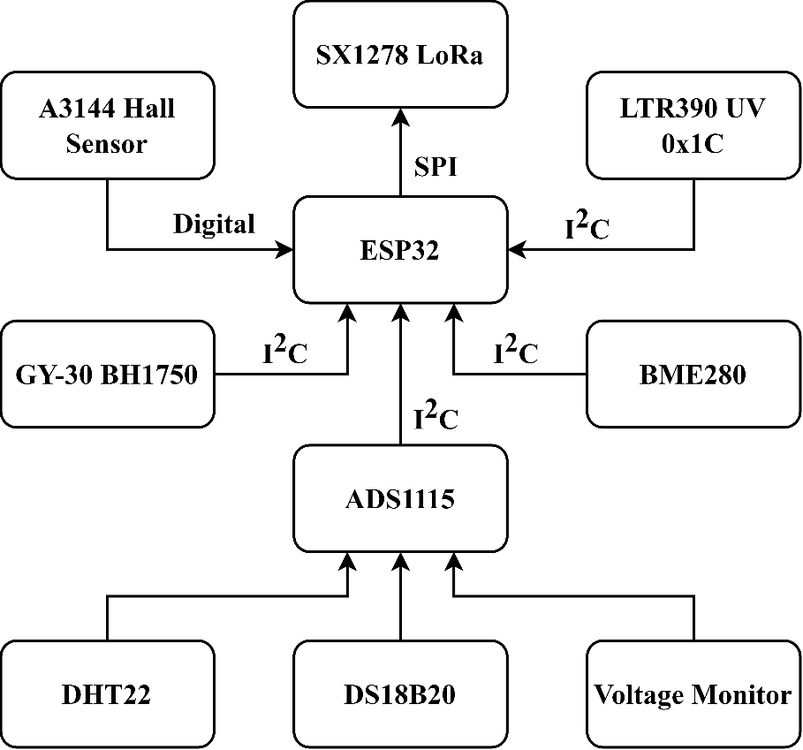**Sensor Interface Diagram :**

**Transmitter Power Plan :**



    
    
    
    
    
    
    
    
    
    